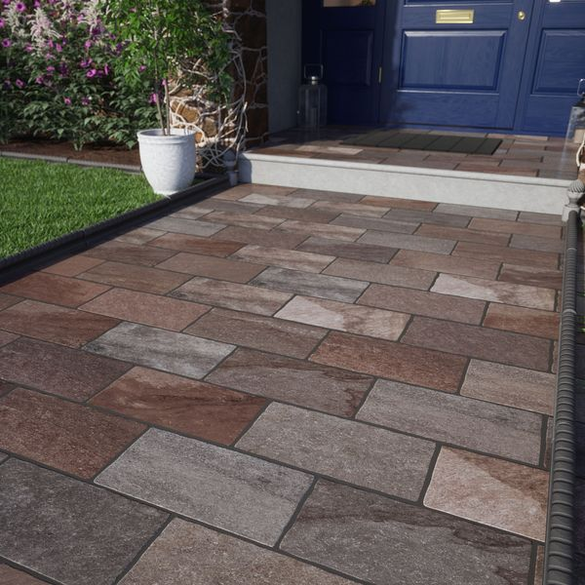**Trail Terra:**

## **Product Description**

Create a timeworn, natural look in your outdoor space with our Trail collection. Inspired by Italian roads and pathways, our Trail Terra Porcelain Paving Slabs feature a realistic stone effect design in various shades of brown and grey, perfect for emulating the rustic look of a natural cobblestone design. Designed in a rectangular format with a natural matt finish and an anti-slip surface, these multifunctional slabs can be used to create multiple unique patterns for a beautiful pathway or larger outdoor spaces.

[object HTMLStyleElement]

Have you tried our 20mm Paving Slab Trims?

**What’s special about these tiles?**

> Inspired by Italian stone pathways

> Natural timeworn appearance

> Deep brown and grey hues

> Rustic cobblestone effect design

> Opportunity for multiple layouts

## **Product Info**

* Product ID: 44966
* Tiles Per SQM: 16.666666666667
* Sale by: Per SQM
* Size: 200x300x18mm
* Weight: 2.39 KG
* Material Type: Porcelain
* Finish: Matt
* Colour: Red
* Suitability: Floors
* Area Of Usage: Internal, External
* Rectified Edge: No
* Underfloor Heating: Yes
* Anti Slip Grade: R11 / 12 Degrees
* Document: [Cleaning & Protection Guide](https://m2.wallsandfloors.co.uk/media/amasty/amfile/attach/v6zDQ2bNO72eOYbIuSFeTd6kQ5FyNJtj.pdf),[20mm Installation Guide](https://m2.wallsandfloors.co.uk/media/amasty/amfile/attach/20mm-installation-guide_4.pdf)
* Thickness (mm): 18
* Color: Red